LASSO Logistic Regression Reveals a Mixed MiRNA and Serum-marker Classifier for Prediction of Immunotherapy Response in Liquid Biopsies of Melanoma Patients

**Marc Bendera; I-Peng Chena; Leonie Bluhmb; Peter Mohrb; Beate Volkmera; Rüdiger Greinerta\***

**Affiliations**

a Department of Molecular Cell Biology, Skin Cancer Center Buxtehude, Elbe Kliniken Buxtehude, Buxtehude, Germany

b Department of Dermatology, Elbe Kliniken Buxtehude, Buxtehude, Germany

**Corresponding Author**

Rüdiger Greinert (Ruediger.Greinert@elbekliniken.de)

**Present/permanent address**

Am Krankenhaus 1, 21614 Buxtehude, Germany

**INTRODUCTION:** Cutaneous malignant melanoma suffers from the highest metastasis rate and mortality among different skin cancer entities. However, with emerging immune checkpoint inhibitor (ICI) therapy, prognosis has significantly improved over the last years. To better assess treatment response stable and reliable biomarkers are needed.

**METHODS:** We gathered blood samples of 81 patients with predominantly AJCC Stage III/IV melanoma to evaluate serum markers and plasma-derived miRNAs. A machine learning model was developed to predict immunotherapy response. Serum markers were measured according to standard clinical routines. Expression levels of 61 miRNAs were quantified via flowcytometry. LASSO logistic regression was fit to the data to predict therapy outcome, emplyoing AUROC as the performance metric. Nested cross-validation was used to mitigate overfitting.

**RESULTS:** Plasma-derived miRNA expression exhibited significant association with therapy response for 5 miRNAs: miR-132-3p, miR-137, miR-197, miR-214, miR-514a-3p. Serum markers LDH, CRP, S100 and eosinophile concentration showed significant differences between Responders and Non-Responders. Age and previous anti-BRAF therapy (BRAFi/MEKi) were the only demographic parameters significantly related to therapy outcome. Among six machine learning models tested, a relaxed LASSO approach on the entire dataset performed best (AUC = 0.851).

**CONCLUSION:** Validation of the relaxed LASSO model in the outer loop of the nested cross validation yielded an AUC of 0.847. This model incorporated expression of a miRNA-quartet, LDH, patient age and prior BRAFi/MEKi. It effectively identifies Responders and Non-Responders with high sensitivity and specificity, presenting promising candidates for the validation of future biomarkers.

**Keywords**

skin cancer;melanoma; liquid biopsies; machine learning; immunotherapy

Introduction

ICI therapy has demonstrated increased clinical efficacy in various solid tumors, including non-small cell lung cancer and melanoma[1, 2]. Malignant melanoma of the skin, in particular, stands out due to its high immunogenicity, making it the tumor type with the most promising outcomes from ICI treatment. Inhibition of the programmed cell death protein 1 (PD-1)/programmed cell death-ligand 1 (PD-L1) checkpoint and the T-lymphocyte-associated protein 4 (CTLA-4) checkpoint has led to improved survival and even durable remission in patients with metastatic melanoma [3, 4]. Despite these successes, a significant percentage of patients exhibit primary resistance to immune checkpoint inhibition. Approximately 60%-70% do not respond to PD-1 monotherapy (nivolumab, pembrolizumab), and 40%-50% are Non-Responders to combined therapy with anti-CTLA-4 (ipilimumab) [5, 6]. Consequently, there is an urgent need for predictive biomarkers to distinguish Responders from Non-Responders to ICI therapy [7].

Several tissue-based predictive biomarkers for PD-1 therapy outcomes have already been identified, including PD-L1 surface expression and tumor mutational burden [8-10]. In melanoma, Madore et al. reported that a lower non-synonymous mutation burden correlated with negative PD-L1 expression on melanoma cells and significantly worse melanoma-specific survival in stage III melanoma (HR = 0.28; 95% CI: 0.12-0.66; p = 0.002) [11, 12]. However, utilizing tissue-specific biomarkers has its drawbacks. Due to the invasive nature of biomarker identification in tissue, its application is limited for repetitive assessments during melanoma progression or throughout therapy to monitor potential changes.

In addressing these challenges, the utilization of liquid biopsies (LB) emerges as a highly promising alternative. Liquid biopsies can be easily obtained from various body fluids, particularly blood. This approach presents a compelling solution, as liquid biopsies offer the key advantage of being minimally invasive, enabling serial repetitions and providing real-time information extraction from the tumor [13]. Numerous liquid biopsy-based biomarkers have already been identified for assessing the outcome of ICI therapy [14], including lactate dehydrogenese (LDH) activity [15] lymphocyte or eosinophil counts [16-19] and antibodies to certain proteins [20]. Notably, recent findings by Ugurel et al. [21] revealed that elevated baseline levels of free circulating serum PD-1 or PD-L1 predict a poor outcome in PD-1 inhibition therapy for metastatic melanoma, adding to the growing repertoire of liquid biopsy-based prognostic indicators.

In recent years, microRNAs (miRNA) have emerged as focal points in research, particularly in understanding the regulatory mechanisms influencing the cellular fate of diverse cell types, ranging from cancer cells [22] to various immune cells [23]. These small RNA sequences, typically 20-24 nucleotides long, function as noncoding entities that epigenetically govern the translation of target mRNAs by binding to the 3'UTR of a majority of human genes [24, 25]. MiRNAs can be easily detected in liquid biopsies, and they exhibit a high degree of stability in various body fluids, including blood, sera, and plasma. This characteristic enables the non-invasive and longitudinal tracking of miRNA expression throughout processes such as tumor development and cancer therapies [26]. Notably, miRNAs facilitate communication between tumor cells and various components of the tumor microenvironment, including cancer-associated fibroblasts, dendritic cells, natural killer cells, and macrophages, as evidenced by numerous studies [23]. Their involvement in both primary and acquired resistance to immunotherapy across various cancer entities, including melanoma, has been well-documented [27, 28]. Furthermore, miRNAs are currently under consideration as promising predictive biomarkers for distinguishing between Responders and Non-Responders to ICI therapies [23, 29]. For instance, studies have demonstrated that the expression of miRNA-222 in melanoma tissue was significantly higher in patients who derived no clinical benefit from Ipilimumab treatment (anti-CTLA-4) compared to Responders Additional miRNAs, which might function as possible predictive biomarkers for ICI-therapies have also been reported recently [23].

Collectively, these findings underscore the growing body of evidence supporting the substantial role of miRNAs in immune responses and therapeutic avenues for cancers, including malignant melanoma of the skin. Additionally, their potential as promising circulating biomarkers is becoming increasingly evident.

Methods

***Study Design and liquid biopsy collection***

Citrate blood samples were systematically obtained during routine blood draws with the explicit informed consent of the patients each time immunotherapy was administered. Subsequently, the collected samples underwent centrifugation for 10 minutes at 1800 x g, resulting in the separation of plasma supernatant. Two milliliters of this plasma supernatant were aliquoted and promptly frozen at -80°C, preserving the samples until miRNA multiplexing analysis.

In cases where baseline visit samples were available, those were utilized. However, if baseline samples were unavailable, the sample collected during the first visit following the initiation of immunotherapy was used. Patient records, containing blood values and other clinically relevant parameters, were referenced for additional contextual information. The entire analysis protocol was ethically sanctioned and received approval from the IRB Ethical Review Board of Hamburg and the medical association of Lower Saxonia.

*miRNA profiling*

As described previously [30], the transcription of miRNAs was measured via flowcytometric quantification of barcode-labelled fluorescent miRNA-hydrogel-microparticle (“FirePlex Particle Technology “, Abcam) according to the manufacturer’s protocol.

*Assessment of BRAF status*

BRAF V600 mutation was inspected both on the forward and reverse strand using pyrosequencing technology. Briefly, a 91-bp region of human BRAF exon 15 spanning the hotspot mutation site at codon 600 was amplified by polymerase chain reaction (PCR) using the primer sequences Braf_Fseq_PCR_F: 5´-tgaagacctcacagtaaaaatagg-3´, Braf_Fseq_PCR_R: 5´-Biotin-tccagacaactgttcaaactgat-3´ for the forward and Braf_Rseq_PCR_F: 5´-Biotin-tgaagacctcacagtaaaaatagg-3´, Braf_Rseq_PCR_R: 5´-tccagacaactgttcaaactgat-3´ for the reverse strand.

Primers were synthesized by Biomers GmbH (Ulm, Germany). Each PCR contained 5 to 50 ng of genomic DNA, primers (0.3 µM), and 17.5 µl of MyTaq™ HS Red Mix (Bioline GmbH, Germany) in a total volume of 35 µl. Cycling was performed in an Eppendorf Mastercycler Gradient (Brinkman Instruments, Westbury, NY) as follows: 95°C for 1 minute, 42 cycles of 95°C for 15 seconds, 58°C for 15 seconds, 72°C for 10 seconds, and a final 30 seconds extension at 72°C. Specific amplification was verified by visualizing 5 µl of the PCR product on a 2% agarose gel containing Serva DNA Stain Clear G (Serva, Heidelberg, Germany). Pyrosequencing was performed using the PyroMark Q24 (Qiagen, Hilden, Germany) according to the manufacturer’s instructions. 10 µl of biotinylated PCR product was immobilized on streptavidin-coated Sepharose high-performance beads (Amersham Biosciences, Piscataway, NJ). The single stranded template was incubated with 0.3 µmol/L sequencing primer (Braf_Fseq_SEQ: 5´- gtaaaaataggtgattttgg-3´ for forward and Braf_Rseq_SEQ: 5´-ccactccatcgagattt-3´ for reverse sequencing) at 80°C for 2 minutes. The sequencing reaction of the complementary strand was performed using PyroMark Gold reagents (Qiagen) and the dispensation order ATTGCTGAGCATACTAGATGAATCT for forward and TCGTATCTGTAG for reverse sequencing. Sequencing runs were analysed using the PyroMark Q24 Software.

*Statistics*

Statistical Analyses were performed in R 4.2.0 or higher (<https://www.r-project.org/>) using the packages *ggpubr* (<https://CRAN.R-project.org/package=ggpubr>) and *rstatix* (<https://CRAN.R-project.org/package=rstatix>). Variables of interest were generally well represented by a normal distribution (after log2-transformation) as assessed by Shapiro-Wilk test and visual inspection of histograms and quantile-quantile plots. Therefore we employed parametric methods for group comparisons as they yield higher statistical power than their non-parametric counterparts. Intergroup comparisons were conducted using Welchs’s t-test due to imbalances in sample variances. No multiple testing adjustment was applied as this was an explorative study and the cost of false negatives was assessed higher than the cost of false positives. P-values < 0.05 were considered significant. Frequencies between groups were compared by chi-square test.

*Machine Learning*

Six machine learning models were developed to assess the power of the data to correctly classify the response of melanoma patients after an anti-PD-L1 immunotherapy on a molecular level in liquid biopsies apart from, and in connection with clinical parameters used by RECIST [31]. Data preprocessing and modelling were done with the R package *caret* (<https://CRAN.R-project.org/package=caret>) offering a variety of ready-to-use functions for machine learning pipelines. Glmnet was the method of choice within the train function of the caret package as it works with small sample sizes and includes regularization via penalized maximum likelihood.

The analysis utilized data from 62 melanoma patients, comprising 27 Responders and 35 Non-Responders. Initially, 75 features, including 61 miRNAs, demographic factors, and clinical characteristics, were employed to predict the outcome. Missing values were imputed by a random forest algorithm provided by the *missForest* (<https://cran.r-project.org/web/packages/missForest/index.html>)package in R. Categorical variables were one-hot encoded and data were standardized by scaling and centering for a better comparability of the respective features. Non-normal features were log-transformed if transformation improved approximation of the sample distribution by a standard normal distribution.

Six different models utilizing a differing set of features were developed and compared in means of prediction ability. To be able to optimize the model and still obtain unbiased estimates with a small sample size, nested cross-validation was applied (Fig. 1). Briefly, in the outer loop data were split into training and test set in a 90:10 ratio for 10-fold cross-validation repeated 10 times. In the inner loop 10-fold cross validation repeated 5 times was employed for model optimization. This included hyperparameter tuning by an exhaustive grid search, feature selection by least absolute shrinkage and selection operator (LASSO, L1 regularization) regression (if applicable) and calculation of the area under receiver operating characteristic curve (AUC).

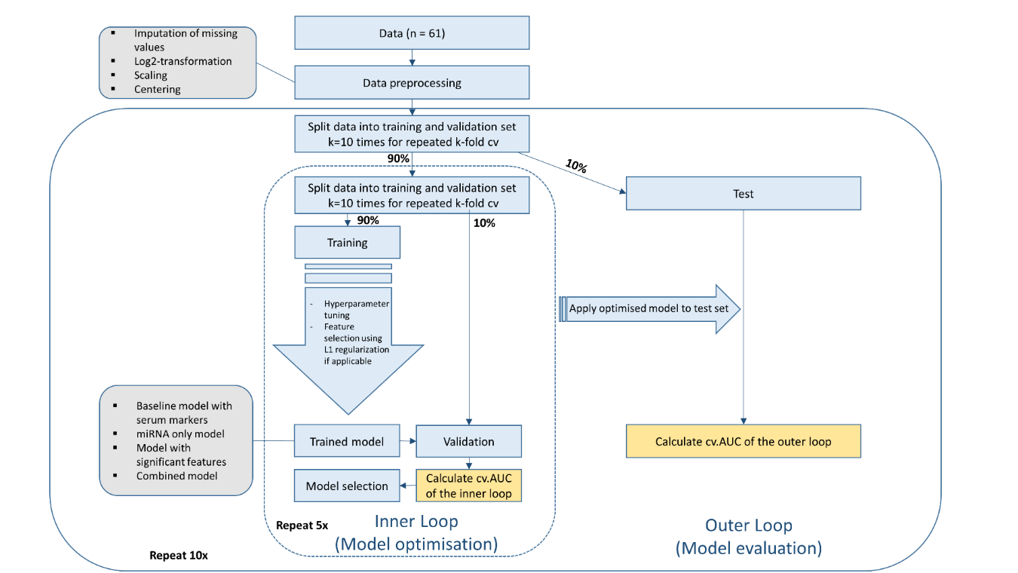

**Fig. 1:** **Workflow of the nested cross-validation approach.** cvAUC: cross-validated area under the curve. cv: cross validation.

For each data split the optimized model generated using the training data was also applied to the respective test data to calculate the AUC on unseen data. Subsequently, the results of the different data splits were averaged (cross validated AUC, cvAUC) and confidence intervals were calculated. Finally, the best classifier was chosen based on the highest cvAUC in the inner loop. Model evaluation was then assessed using the cvAUC of the outer loop.

Results

***Patient and tumor characteristics***

For this study we included a total of 81 melanoma patients who were treated with immunotherapy and assessed therapy response based on RECIST criteria [31]. In the following, patients who responded to ICI are referred to as Responders and patients with therapy failure are referred to as Non-Responders. Patient demographics and tumor characteristics grouped by response status are shown in Table 1 and Table 2, respectively. The cohort predominantly consisted of patients in AJCC Stage IV (82.7%), a balanced 50:50 split of patients with and without BRAF mutation and 51.9% or 35.8% of patients reporting ECOG performance scores of 0 or 1, respectively.

Differences between Responders and Non-Responders were present for the covariate age (chi², p = 0.0319) with a higher median age in Responders (73.0 years vs. 57.5 years) and if patients received anti-BRAF/MEK therapy prior to immunotherapy (chi², p = 0.0081) with a higher proportion of patients receiving anti-BRAF therapy in Non-Responders (40.0%) compared to Responders (16.7%).

**Table 1: Patient demographics grouped by response to ICI.**

|  |  |  |  |  |
| --- | --- | --- | --- | --- |
|  | **Non-Responders (N=45)** | **Responders (N=36)** | **Overall**  **(N=81)** | **P-value** |
| **Age (years)** |  |  |  |  |
| Mean (SD) | 59.4 (17.1) | 68.0 (14.3) | 63.5 (16.3) | 0.0319 |
| Median [Min, Max] | 57.5 [31.0, 87.0] | 73.0 [36.0, 92.0] | 69.0 [31.0, 92.0] |  |
| Missing | 11 (24.4%) | 5 (13.9%) | 16 (19.8%) |  |
| **Prior BRAFi/MEKi therapy** |  |  |  |  |
| No | 15 (33.3%) | 25 (69.4%) | 40 (49.4%) | 0.0081 |
| Yes | 18 (40.0%) | 6 (16.7%) | 24 (29.6%) |  |
| Missing | 12 (26.7%) | 5 (13.9%) | 17 (21.0%) |  |
| **Prior adjuvant IFNγ treatment** |  |  |  |  |
| No | 19 (42.2%) | 19 (52.8%) | 38 (46.9%) | 1 |
| Yes | 10 (22.2%) | 10 (27.8%) | 20 (24.7%) |  |
| Missing | 16 (35.6%) | 7 (19.4%) | 23 (28.4%) |  |
| **Sex** |  |  |  |  |
| Male | 25 (55.6%) | 23 (63.9%) | 48 (59.3%) | 0.595 |
| Female | 20 (44.4%) | 13 (36.1%) | 33 (40.7%) |  |
| **ECOG performance status** |  |  |  |  |
| 0 | 19 (42.2%) | 23 (63.9%) | 42 (51.9%) | 0.094 |
| 1 | 18 (40.0%) | 11 (30.6%) | 29 (35.8%) |  |
| ≥2 | 8 (17.8%) | 2 (5.6%) | 10 (12.3%) |  |

BRAFi/MEKi: Treatment with BRAF/MEK inhibitors. ECOG: Eastern Cooperative Oncology Group. IFNγ: Interferon-γ. Statistical test for categorical data: chi²-test. Statistical test for numerical data: Unequal variances t-test (Welch’s t-test).

**Table 2: Tumor characteristics grouped by response to ICI.**

|  |  |  |  |  |
| --- | --- | --- | --- | --- |
|  | **Non-Responders (N=45)** | **Responders (N=36)** | **Overall**  **(N=81)** | **P-value** |
| **BRAF-status** |  |  |  |  |
| Wildtype | 17 (37.8%) | 23 (63.9%) | 40 (49.4%) | 0.0536 |
| Mutated | 26 (57.8%) | 13 (36.1%) | 39 (48.1%) |  |
| Missing | 2 (4.4%) | 0 (0%) | 2 (2.5%) |  |
| **AJCC stage (8th edition)** |  |  |  |  |
| II | 0 (0%) | 1 (2.8%) | 1 (1.2%) | 0.498 |
| III | 6 (13.3%) | 4 (11.1%) | 10 (12.3%) |  |
| IV | 39 (86.7%) | 28 (77.8%) | 67 (82.7%) |  |
| Missing | 0 (0%) | 3 (8.3%) | 3 (3.7%) |  |
| **Brain metastasis** |  |  |  |  |
| No | 16 (35.6%) | 18 (50.0%) | 34 (42.0%) | 0.62 |
| Yes | 10 (22.2%) | 7 (19.4%) | 17 (21.0%) |  |
| Missing | 19 (42.2%) | 11 (30.6%) | 30 (37.0%) |  |
| **Subtype** |  |  |  |  |
| Cutaneous | 40 (88.9%) | 31 (86.1%) | 71 (87.7%) | 0.807 |
| Mucosal | 2 (4.4%) | 3 (8.3%) | 5 (6.2%) |  |
| Missing | 3 (6.7%) | 2 (5.6%) | 5 (6.2%) |  |

AJCC staging (8th edition): American Joint Committee of Cancer staging system for melanoma. Statistical test for categorical data: chi²-test. Statistical test for numerical data: Unequal variances t-test (Welch’s t-test).

***Differential miRNA expression is associated with response to immunotherapy***

To assess the ability of miRNA expression to predict outcome of immunotherapy and function as a classifier in liquid biopsies we simultaneously investigated 61 manually curated miRNAs (associated with melanoma or carcinogenesis based on literature research) using the flow-cytometric FirePlex® Assay (Abcam). Out of the 81 patients, plasma of only 61 patients was assessable for miRNA analyses. Two-sided unequal variances t-test (Welch’s t-test) was conducted to examine miRNA expression between Responders and Non-Responders. Four miRNAs were significantly upregulated (miR-132-3p, p = 0.025; miR-137, p = 0.022; miR-214-3p, p = 0.038; miR-514a-3p, p = 0.048) and one miRNA was significantly downregulated (miR-197-3p, p = 0.033) in Responders (Fig. 2).

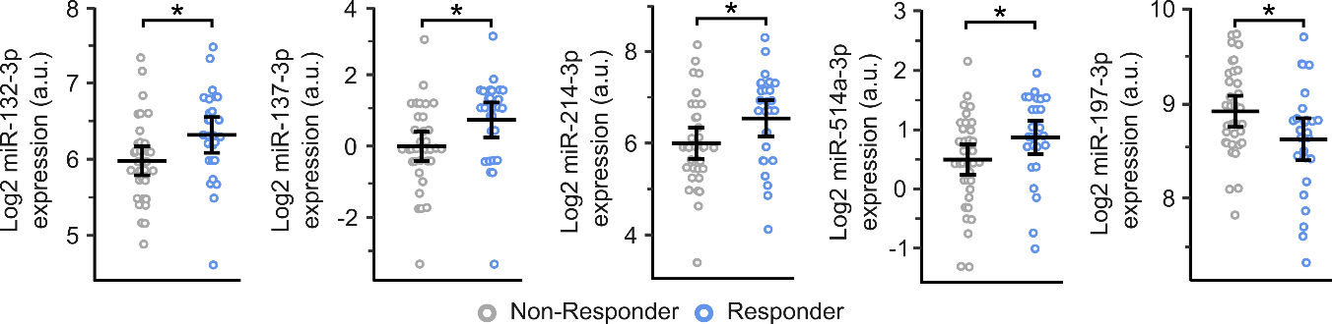**Fig. 2:** **Log-2 miRNA expression in melanoma patients grouped by immunotherapy response.** Expression has been determined by FirePlex®-assay. Crossbars show mean ± sd. Statistics: unequal variances t-test (Welch’s t-test). Grey: Non-responder. Blue: Responder. *: p<0.05.

***Analysis of serum melanoma markers CRP, LDH, S100 and eosinophils***

In addition to miRNA expression, the concentration of four serum markers known to have prognostic value in melanoma patients was scrutinized. Low concentrations of c-reactive protein (CRP, p = 0.002), lactate dehydrogenase (LDH, p < 0.001) and S100 (p = 0.002) as well as high concentration of eosinophils (p = 0.013) were positively associated with therapy response (Fig. 3).

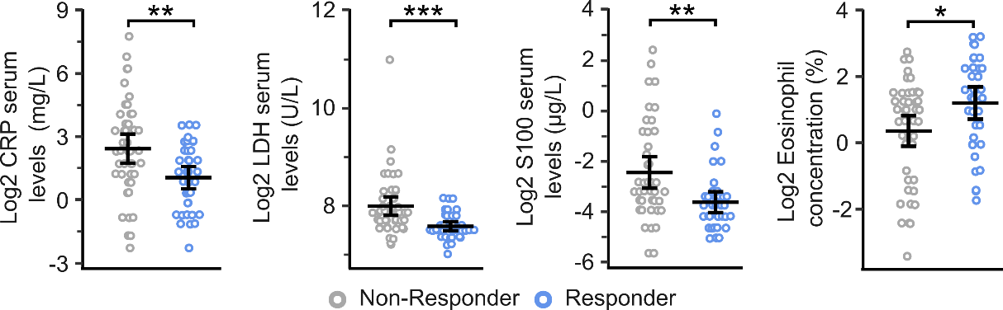

**Fig. 3:** **Log-2 serum marker concentration.** Crossbars show mean ± sd. Statistics: unequal variances t-test (welch’s t-test). Grey: Non-responder. Blue: Responder. CRP: c-reactive protein. LDH: lactate dehydrogenase. *: p<0.05; **: p<0.01; ***: p<0.001.

***Development of a machine learning model***

The prediction of immunotherapy response requires different covariates, also referred to as features, that are associated to therapy outcome. The choice of features is a crucial process which substantially determines prediction quality. Therefore we examined six different models each using a different set of features and nested cross validation (detailed explanation in Fig. 1) to predict therapy outcome (Fig. 4A). The underyling algorithm was a penalized logistic regression applied through the glmnet method within *caret’s* train function.

The first model was a baseline model only using the serum markers CRP, LDH, S100 and eosinophils for prediction. As these are known prognostic markers, performance of other models was compared to this model. The cross validated AUC (cvAUC) for this model was determined by averaging the AUC for each iteration of the cross validation in the inner loop using the R package *cvAUC* ([https://cran.r-project.org/web/packages/cvAUC/ index.html](https://cran.r-project.org/web/packages/cvAUC/%20index.html)) which also generates 95% confidence intervals in the output. The cvAUC (95% CI) for this baseline model was 0.743 (0.687-0.798).

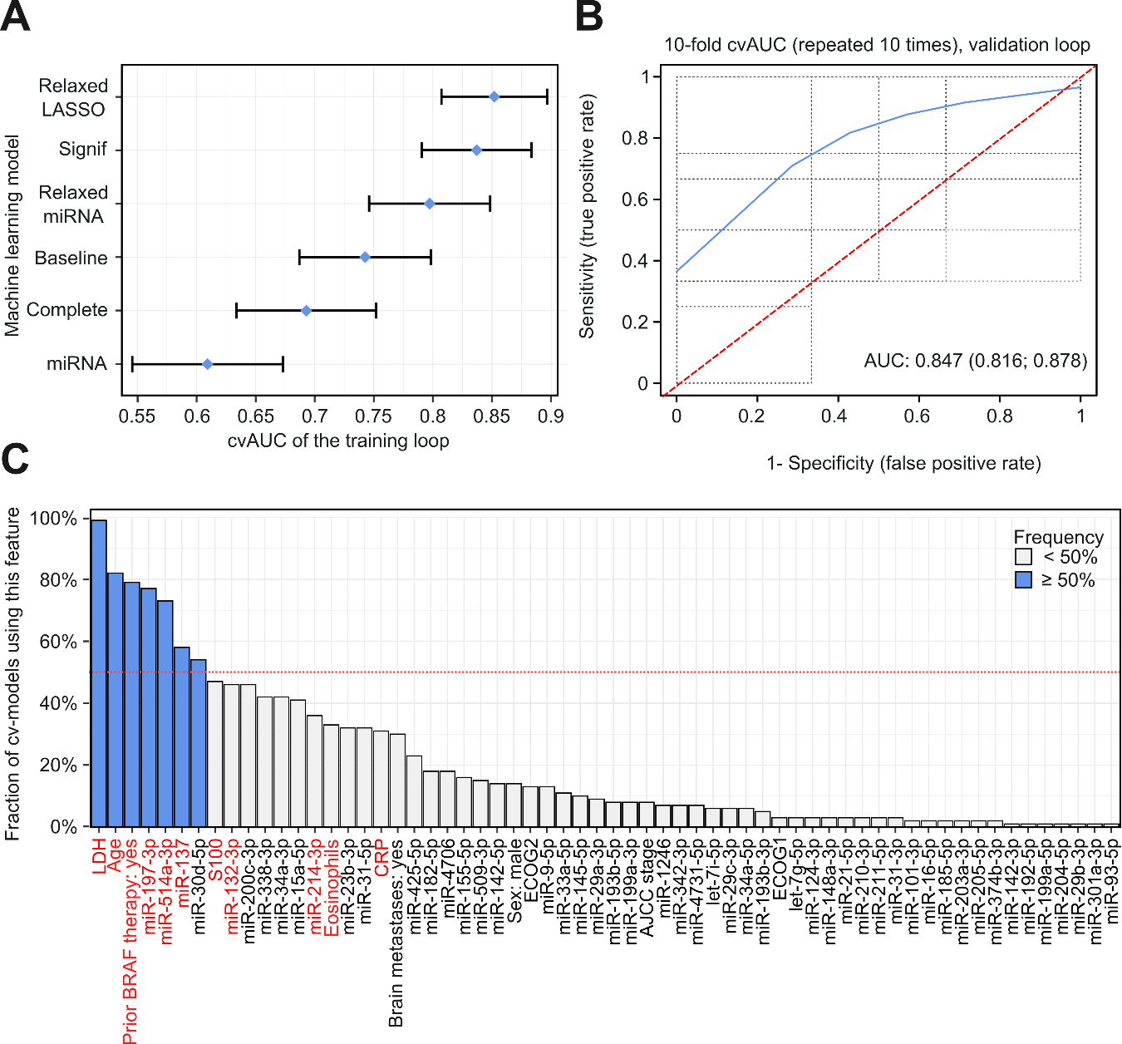

**Fig. 4:** **Development of a machine learning model. (A):** *Model selection based on cvAUC.*Calculation of cross-validated AUC as described in the workflow passage (Fig. 1). Blue dots indicate the mean cvAUC for each model. Error bars indicate 95% confidence intervals. (**B):***Model evaluation in the outer loop of nested cross validation.*Application of the *relaxedLasso* model on the test set in the outer loop resulted in different performances in each iteration (grey lines). Red dottet line: random classifier. Blue line: combined ROC curve for the cross validation process. AUC: area under the curve. Values in parentheses indicate 95% confidence interval for the AUC. (**C):** *Feature importance in the feature selection process.*Features used in more than 50% of the iterations in the first LASSO regression were considered important. Grey: features below the 50% threshold. Blue: features above the 50% threshold. Red dotted line indicates 50%. Significantly changed features are depicted in red.

A model utilizing all examined miRNAs [cvAUC (95% CI): 0.609 (0.546-0.673), referred to as *miRNA*] and a model using all available features [cvAUC (95% CI): 0.692 (0.633-0.752), referred to as *Complete*] performed worse than the baseline model, possibly due to a low signal-to-noise ratio caused by the high number of input features. When using only significant features (miRNAs shown in Fig. 2 and serum markers shown in Fig. 3, as well as age and prior BRAFi/MEKi therapy) model performance improved substantially [cvAUC (95% CI): 0.837 (0.791-0.883), referred to as *Signif*]. Removal of miRNAs from the *Signif* model led to impairment of model performance [cvAUC (95% CI): 0.793 (0.743-0.844)], whereas utilizing only significantly changed miRNAs yielded a cvAUC (95% CI) of 0.719 (0.661-0.776). This shows a combination of different types of predictors might enhance predictive ability of machine learning models.

Finally, an approach similar to relaxed LASSO as described by Meinshausen [32] was employed where in a two-step process features are selected by LASSO regression and these selected features were used as input in a second LASSO regression to calculate performance metrics. This relaxed LASSO was applied to two different sets of features to eliminate uninformative covariates. First, it was used in the whole set of 61 miRNAs to reduce the amount of dispensable features resulting in 15 miRNAs used as input in the second iteration of the LASSO regression which yielded a cvAUC (95% CI) of 0.797 (0.746-0.848) (referred to as *Relaxed miRNA)*. The best performance, though, could be achieved when all variables were used as input of the relaxed LASSO, which then eliminated uninformative variables [cvAUC (95% CI): 0. 851 (0.807-0.897), referred to as *Relaxed LASSO*].

Validation of the *Relaxed LASSO* model in the outer loop (Fig. 4B) showed high consistency with a cvAUC (95% CI) of 0.847 (0.816-0.878). These estimates approximate those obtained in the inner loop for training and thus confirm a good generalizability of the model. In this *winning (Relaxed LASSO,* see Fig. 4A) model, seven features were used in more than 50% of the iterations and thus considered important (Fig. 4C). The most important feature was LDH (included in 99.0% of the cv-models), followed by age (82.0%), prior BRAFi/MEKi (79.0%), miR-197-3p expression (77.0%), miR-514a-3p expression (73.0%), miR-137 expression (58.0%) and miR-30d-5p expression (54.0%). A high expression of miR-30d-5p, miR-137 and miR-514a-3p as well as higher patient age were associated with an increased chance of therapy success. On the other hand, high expression of miR-197-3p, high concentration of LDH and prior BRAFi/MEKi were associated with therapy failure.

Six out of these seven features were also significantly changed between Responders and Non-Responders with the exception of miR-30d-5p, which was not differentially expressed but still possessed predictive potential when combined with the other covariates. On the other hand there were two miRNAs (miR-132-3p, miR-214-3p) and three serum markers (CRP, S100, Eosinophils) which were differentially expressed (Fig. 2 and Fig. 3, respectively) but did not reach the 50%-threshold. However, they were all located in the upper third of the important features, also represented by the good performance (2nd highest cvAUC) of the *Signif* model.

Discussion

The aim of this study was to identify differences between Responders and Non-Responders to immunotherapy with a focus on miRNA expression in plasma of melanoma patients to develop a liquid-biopsy classifier.

miR-132-3p is associated with higher response rates in our study and also described as a tumorsuppresor in SCC, hepatocellular carcinoma and melanoma [33]. Analogously, miR-137 inhibits cell proliferation [34], migration [35] and invasion [36] of melanoma and is elevated in Responders. A similar tumorsuppressive role is evident for miR-514a-3p, which is overexpressed in Responders [37]. miR-214-3p is correlated with better response in our study, in contrast to other publications showing a promotion of EMT in melanoma orchestrated by miR-214-3p [38, 39]. However, depending on cell context this miRNA may also act as a tumor suppressor [39]. Indeed, Penna et. al describe the ambivalent character of miR-214-3p in various tumor entities [40]. There is scarce data for miR-197-3p which correlated with therapy failure in our study, though it has been described that miR-197-3p promotes metastasis in hepatocellular carcinoma by activating Wnt/β-Catenin Signaling [41]. High levels of LDH and S100 have been correlated to more advanced melanoma and are associated with worse prognosis. Their use as biomarker has already been validated [42], therefore it was expected to observe elevated levels of LDH and S100 in Non-Responders. Although not recognized as a validated biomarker, CRP elevation also correlated with poor survival [43] and accordingly CRP levels were higher in Non-Responders than in Responders. In contrast, eosinophile count is linked to better survival [44] and elevated in Responders. Finally, elderly patients showed better response to ICI similar to a study from 2018 [45]. As prior BRAFi/MEKi application is associated with age (younger patients more commonly have BRAF mutated tumors and therefore receive BRAFi/MEKi more frequently) it is expected that prior BRAFi/MEKi application would correlate negatively with therapy response as well. However, it is not an exclusively age related effect, as a prior BRAFi/MEKi therapy also reduced response within the group of younger patients in the study of Kugel et al. [45]. Moreover, recent data show a worse survival of patients receiving immunotherapy as 2nd line treatment after 1st line BRAFi/MEKi, supporting the notion that a prior treatment with BRAFi/MEKi impairs immunotherapy response [46].

These significantly changed features were utilized to develop a penalized logistic regression model which was able to separate Responders from Non-Responders with high certainty [*Signif*, cvAUC (95% CI): 0.837 (0.791-0.883)] outperforming the models *miRNA* (all miRNAs), *Complete* (all features)*, Baseline* (four serum markers)and *Relaxed miRNA* (miRNAs selected by relaxed LASSO). The improved performance over the *Baseline* model is of particular interest as it shows that combination of different biological endpoints with patient demographics and treatment history yields more prognostic potential than the use of only serum markers. However, at the cost of simplicity in the modelling process, performance could be further enhanced by application of the two-step relaxed LASSO procedure [*Relaxed LASSO*, cvAUC (95% CI): 0.851 (0.807-0.897)]. The seven feature signature (LDH, age, prior BRAFi/MEKi therapy, low miR-197-3p expression, high miR-514a-3p/miR-137/miR-30d-5p expression) showed a high overlap with the features from the *Signif* model, with the exception of miR-30d-5p, which was not differentially expressed but still possessed predictive potential [47]. On the other hand, serum markers like S100 or CRP were omitted in the *Relaxed LASSO* model, whereas LDH was included in 99.0% of the iterations and the most important feature. This phenomenon is explained in a study by Lo et. al [47] in which simulation experiments showed that significant features are not always good predictors and good predictors do not necessarily need to be significantly changed between groups.

The serum markers likely reflect comparable aspects of the disease, such as tumor load. Hence, including all serum markers would likely introduce noise rather than providing useful information. Overall, this indicates that combining different features that capture diverse patient and disease characteristics outperforms models based solely on single markers or a singular biological entity. This could be expanded by other informative variables like proteomics, epigenetic modifications, analysis of mutational load or exosome analyses in future studies. Though, while increasing accuracy and prediction performance, added complexity might render a prediction model unfeasible for clinical practice. Therefore the proposed model in this study offers a good balance between high performance and applicability as parameters like age, LDH and a prior BRAF therapy are registered in standard melanoma care and merely expression of four miRNAs needs to be measured additionally. However, there are some limitations of this study. Especially the relatively small sample size poses a challenge for machine learning applications as it increases the risk of overfitting [48] W e tried to mitigate this problem with the nested cv-approach but cannot rule out that our results are still biased. Therefore it would be important to validate these findings in an independent cohort to investigate the potential use as biomarkers in liquid biopsies

Conclusions

In this study we were able to establish a machine learning model which is able to distinguish melanoma patients responding to immunotherapy (Responders) from patients with therapy failure (Non-Responders) utilizing a set of seven distinct features, including expression of four miRNAs, LDH serum levels, patient age and a BRAF therapy prior to immunotherapy. After validation in an independent cohort these features could be used as a biomarker for immunotherapy success in melanoma patients.

**Funding Sources**

This research was supported by Bristol Myers Squibb GmbH & Co.KGaA, Munich, Germany.

**Ethic committee approval**

We got the ethical approval for this study by the IRB Ethical Review Board of Hamburg and the medical association of Lower Saxonia for analysis of human materials and all patients gave their written informed consent for this study.

**Author Contributions**

M.B.: Conceptualization, Formal Analysis, Methodology, Software, Visualization, Writing – original draft, Writing – review. I-P.C.: Investigation, Methodology, Writing – review. L.B.: Data curation, Resources, Writing – review. P.M.: Resources, Writing – review. B.V.: Conceptualization, Funding acquisition, Supervision, Writing – review. R.G.: Conceptualization, Funding acquisition, Project administration, Supervision, Writing – original draft. Writing – review.

**References**

1. **1. Swart M, Verbrugge I, Beltman JB: Combination Approaches with Immune-Checkpoint Blockade in Cancer Therapy. *Front Oncol* 2016, 6:233.**
2. **2. Khair DO, Bax HJ, Mele S, Crescioli S, Pellizzari G, Khiabany A, Nakamura M, Harris RJ, French E, Hoffmann RM *et al*: Combining Immune Checkpoint Inhibitors: Established and Emerging Targets and Strategies to Improve Outcomes in Melanoma. *Front Immunol* 2019, 10:453.**
3. **3. Ugurel S, Rohmel J, Ascierto PA, Flaherty KT, Grob JJ, Hauschild A, Larkin J, Long GV, Lorigan P, McArthur GA *et al*: Survival of patients with advanced metastatic melanoma: the impact of novel therapies-update 2017. *Eur J Cancer* 2017, 83:247-257.**
4. **4. Schadendorf D, van Akkooi ACJ, Berking C, Griewank KG, Gutzmer R, Hauschild A, Stang A, Roesch A, Ugurel S: Melanoma. *Lancet* 2018, 392(10151):971-984.**
5. **5. Larkin J, Chiarion-Sileni V, Gonzalez R, Grob JJ, Cowey CL, Lao CD, Schadendorf D, Dummer R, Smylie M, Rutkowski P *et al*: Combined Nivolumab and Ipilimumab or Monotherapy in Untreated Melanoma. *N Engl J Med* 2015, 373(1):23-34.**
6. **6. Robert C, Schachter J, Long GV, Arance A, Grob JJ, Mortier L, Daud A, Carlino MS, McNeil C, Lotem M *et al*: Pembrolizumab versus Ipilimumab in Advanced Melanoma. *N Engl J Med* 2015, 372(26):2521-2532.**
7. **7. Pagni F, Guerini-Rocco E, Schultheis AM, Grazia G, Rijavec E, Ghidini M, Lopez G, Venetis K, Croci GA, Malapelle U *et al*: Targeting Immune-Related Biological Processes in Solid Tumors: We do Need Biomarkers. *Int J Mol Sci* 2019, 20(21).**
8. **8. Topalian SL, Taube JM, Anders RA, Pardoll DM: Mechanism-driven biomarkers to guide immune checkpoint blockade in cancer therapy. *Nat Rev Cancer* 2016, 16(5):275-287.**
9. **9. Axelrod ML, Johnson DB, Balko JM: Emerging biomarkers for cancer immunotherapy in melanoma. *Semin Cancer Biol* 2018, 52(Pt 2):207-215.**
10. **10. Goodman AM, Kato S, Bazhenova L, Patel SP, Frampton GM, Miller V, Stephens PJ, Daniels GA, Kurzrock R: Tumor Mutational Burden as an Independent Predictor of Response to Immunotherapy in Diverse Cancers. *Mol Cancer Ther* 2017, 16(11):2598-2608.**
11. **11. Madore J, Strbenac D, Vilain R, Menzies AM, Yang JY, Thompson JF, Long GV, Mann GJ, Scolyer RA, Wilmott JS: PD-L1 Negative Status is Associated with Lower Mutation Burden, Differential Expression of Immune-Related Genes, and Worse Survival in Stage III Melanoma. *Clin Cancer Res* 2016, 22(15):3915-3923.**
12. **12. Kambayashi Y, Fujimura T, Hidaka T, Aiba S: Biomarkers for Predicting Efficacies of Anti-PD1 Antibodies. *Front Med (Lausanne)* 2019, 6:174.**
13. **13. Lianidou E, Pantel K: Liquid biopsies. *Genes Chromosomes Cancer* 2019, 58(4):219-232.**
14. **14. Lim SY, Lee JH, Diefenbach RJ, Kefford RF, Rizos H: Liquid biomarkers in melanoma: detection and discovery. *Mol Cancer* 2018, 17(1):8.**
15. **15. Diem S, Kasenda B, Spain L, Martin-Liberal J, Marconcini R, Gore M, Larkin J: Serum lactate dehydrogenase as an early marker for outcome in patients treated with anti-PD-1 therapy in metastatic melanoma. *Br J Cancer* 2016, 114(3):256-261.**
16. **16. Weide B, Martens A, Hassel JC, Berking C, Postow MA, Bisschop K, Simeone E, Mangana J, Schilling B, Di Giacomo AM *et al*: Baseline Biomarkers for Outcome of Melanoma Patients Treated with Pembrolizumab. *Clin Cancer Res* 2016, 22(22):5487-5496.**
17. **17. Martens A, Wistuba-Hamprecht K, Yuan J, Postow MA, Wong P, Capone M, Madonna G, Khammari A, Schilling B, Sucker A *et al*: Increases in Absolute Lymphocytes and Circulating CD4+ and CD8+ T Cells Are Associated with Positive Clinical Outcome of Melanoma Patients Treated with Ipilimumab. *Clin Cancer Res* 2016, 22(19):4848-4858.**
18. **18. Martens A, Wistuba-Hamprecht K, Geukes Foppen M, Yuan J, Postow MA, Wong P, Romano E, Khammari A, Dreno B, Capone M *et al*: Baseline Peripheral Blood Biomarkers Associated with Clinical Outcome of Advanced Melanoma Patients Treated with Ipilimumab. *Clin Cancer Res* 2016, 22(12):2908-2918.**
19. **19. Ferrucci PF, Gandini S, Cocorocchio E, Pala L, Baldini F, Mosconi M, Antonini Cappellini GC, Albertazzi E, Martinoli C: Baseline relative eosinophil count as a predictive biomarker for ipilimumab treatment in advanced melanoma. *Oncotarget* 2017, 8(45):79809-79815.**
20. **20. Fassler M, Diem S, Mangana J, Hasan Ali O, Berner F, Bomze D, Ring S, Niederer R, Del Carmen Gil Cruz C, Perez Shibayama CI *et al*: Antibodies as biomarker candidates for response and survival to checkpoint inhibitors in melanoma patients. *J Immunother Cancer* 2019, 7(1):50.**
21. **21. Ugurel S, Schadendorf D, Horny K, Sucker A, Schramm S, Utikal J, Pfohler C, Herbst R, Schilling B, Blank C *et al*: Elevated baseline serum PD-1 or PD-L1 predicts poor outcome of PD-1 inhibition therapy in metastatic melanoma. *Ann Oncol* 2020, 31(1):144-152.**
22. **22. Dragomir M, Mafra ACP, Dias SMG, Vasilescu C, Calin GA: Using microRNA Networks to Understand Cancer. *Int J Mol Sci* 2018, 19(7).**
23. **23. Nguyen MT, Luo YH, Li AL, Tsai JC, Wu KL, Chung PJ, Ma N: miRNA as a Modulator of Immunotherapy and Immune Response in Melanoma. *Biomolecules* 2021, 11(11).**
24. **24. O'Brien J, Hayder H, Zayed Y, Peng C: Overview of MicroRNA Biogenesis, Mechanisms of Actions, and Circulation. *Front Endocrinol (Lausanne)* 2018, 9:402.**
25. **25. Gajos-Michniewicz A, Czyz M: Role of miRNAs in Melanoma Metastasis. *Cancers (Basel)* 2019, 11(3).**
26. **26. Pardini B, Sabo AA, Birolo G, Calin GA: Noncoding RNAs in Extracellular Fluids as Cancer Biomarkers: The New Frontier of Liquid Biopsies. *Cancers (Basel)* 2019, 11(8).**
27. **27. Varrone F, Caputo E: The miRNAs Role in Melanoma and in Its Resistance to Therapy. *Int J Mol Sci* 2020, 21(3).**
28. **28. Motti ML, Minopoli M, Di Carluccio G, Ascierto PA, Carriero MV: MicroRNAs as Key Players in Melanoma Cell Resistance to MAPK and Immune Checkpoint Inhibitors. *Int J Mol Sci* 2020, 21(12).**
29. **29. Nakahara S, Fukushima S, Okada E, Morinaga J, Kubo Y, Tokuzumi A, Matsumoto S, Tsuruta-Kadohisa M, Kimura T, Kuriyama H *et al*: MicroRNAs that predict the effectiveness of anti-PD-1 therapies in patients with advanced melanoma. *J Dermatol Sci* 2020, 97(1):77-79.**
30. **30. Bender M, Chen IP, Henning S, Degenhardt S, Mhamdi-Ghodbani M, Starzonek C, Volkmer B, Greinert R: Knockdown of Simulated-Solar-Radiation-Sensitive miR-205-5p Does Not Induce Progression of Cutaneous Squamous Cell Carcinoma In Vitro. *Int J Mol Sci* 2023, 24(22).**
31. **31. Eisenhauer EA, Therasse P, Bogaerts J, Schwartz LH, Sargent D, Ford R, Dancey J, Arbuck S, Gwyther S, Mooney M *et al*: New response evaluation criteria in solid tumours: revised RECIST guideline (version 1.1). *Eur J Cancer* 2009, 45(2):228-247.**
32. **32. Meinshausen N: Relaxed LASSO. *Comput Stat Data Anal* 2007, 52:374-398.**
33. **33. Caramuta S, Egyhazi S, Rodolfo M, Witten D, Hansson J, Larsson C, Lui WO: MicroRNA expression profiles associated with mutational status and survival in malignant melanoma. *J Invest Dermatol* 2010, 130(8):2062-2070.**
34. **34. Lv N, Hao S, Luo C, Abukiwan A, Hao Y, Gai F, Huang W, Huang L, Xiao X, Eichmuller SB *et al*: miR-137 inhibits melanoma cell proliferation through downregulation of GLO1. *Sci China Life Sci* 2018, 61(5):541-549.**
35. **35. Peres J, Kwesi-Maliepaard EM, Rambow F, Larue L, Prince S: The tumour suppressor, miR-137, inhibits malignant melanoma migration by targetting the TBX3 transcription factor. *Cancer Lett* 2017, 405:111-119.**
36. **36. Luo C, Tetteh PW, Merz PR, Dickes E, Abukiwan A, Hotz-Wagenblatt A, Holland-Cunz S, Sinnberg T, Schittek B, Schadendorf D *et al*: miR-137 inhibits the invasion of melanoma cells through downregulation of multiple oncogenic target genes. *J Invest Dermatol* 2013, 133(3):768-775.**
37. **37. Stark MS, Klein K, Weide B, Haydu LE, Pflugfelder A, Tang YH, Palmer JM, Whiteman DC, Scolyer RA, Mann GJ *et al*: The Prognostic and Predictive Value of Melanoma-related MicroRNAs Using Tissue and Serum: A MicroRNA Expression Analysis. *EBioMedicine* 2015, 2(7):671-680.**
38. **38. Wang SJ, Li WW, Wen CJ, Diao YL, Zhao TL: MicroRNA‑214 promotes the EMT process in melanoma by downregulating CADM1 expression. *Mol Med Rep* 2020, 22(5):3795-3803.**
39. **39. Lu T, Yang Y, Li Z, Lu S: MicroRNA-214-3p inhibits the stem-like properties of lung squamous cell cancer by targeting YAP1. *Cancer Cell Int* 2020, 20:413.**
40. **40. Penna E, Orso F, Taverna D: miR-214 as a key hub that controls cancer networks: small player, multiple functions. *J Invest Dermatol* 2015, 135(4):960-969.**
41. **41. Hu Z, Wang P, Lin J, Zheng X, Yang F, Zhang G, Chen D, Xie J, Gao Z, Peng L *et al*: MicroRNA-197 Promotes Metastasis of Hepatocellular Carcinoma by Activating Wnt/beta-Catenin Signaling. *Cell Physiol Biochem* 2018, 51(1):470-486.**
42. **42. Wang J, Wang H, Liu A, Fang C, Hao J, Wang Z: Lactate dehydrogenase A negatively regulated by miRNAs promotes aerobic glycolysis and is increased in colorectal cancer. *Oncotarget* 2015, 6(23):19456-19468.**
43. **43. Fang S, Wang Y, Sui D, Liu H, Ross MI, Gershenwald JE, Cormier JN, Royal RE, Lucci A, Schacherer CW *et al*: C-reactive protein as a marker of melanoma progression. *J Clin Oncol* 2015, 33(12):1389-1396.**
44. **44. Moreira A, Leisgang W, Schuler G, Heinzerling L: Eosinophilic count as a biomarker for prognosis of melanoma patients and its importance in the response to immunotherapy. *Immunotherapy* 2017, 9(2):115-121.**
45. **45. Kugel CH, 3rd, Douglass SM, Webster MR, Kaur A, Liu Q, Yin X, Weiss SA, Darvishian F, Al-Rohil RN, Ndoye A *et al*: Age Correlates with Response to Anti-PD1, Reflecting Age-Related Differences in Intratumoral Effector and Regulatory T-Cell Populations. *Clin Cancer Res* 2018, 24(21):5347-5356.**
46. **46. Atkins MB, Lee SJ, Chmielowski B, Tarhini AA, Cohen GI, Truong TG, Moon HH, Davar D, O'Rourke M, Stephenson JJ *et al*: Combination Dabrafenib and Trametinib Versus Combination Nivolumab and Ipilimumab for Patients With Advanced BRAF-Mutant Melanoma: The DREAMseq Trial-ECOG-ACRIN EA6134. *J Clin Oncol* 2023, 41(2):186-197.**
47. **47. Lo A, Chernoff H, Zheng T, Lo SH: Why significant variables aren't automatically good predictors. *Proc Natl Acad Sci U S A* 2015, 112(45):13892-13897.**
48. **48. Charilaou P, Battat R: Machine learning models and over-fitting considerations. *World J Gastroenterol* 2022, 28(5):605-607.**